**1.0 Global Profile of the Company**

Nestlé, a Swiss multinational food and beverage corporation, is a prominent global leader in the industry (Huang, 2023). Established in 1866, the corporation has developed into a dominant force, overseeing a wide range of popular brands (Alexander *et al*., 2011). Nestlé's dedication to the purpose of "Good Food, Good Life" highlights its commitment to providing high-quality, nourishing goods that improve the lives of people worldwide (Sánchez *et al*., 2016). The company offers a wide range of products, including coffee, chocolate, infant nutrition, and pet care (Marin & Verdier, 2007).

**Mission**

The company's mission, encapsulated in its tagline "Good Food, Good Life," reflects its commitment to offering consumers the best tasting and most nutritious choices across a wide range of food and beverage categories throughout the day.

**Vision**

The company's vision includes sustainable and responsible business practices, prioritizing innovation and renovation of its product portfolio to meet evolving consumer needs, particularly in the areas of health and wellness. Nestlé leverages its global scale and resources to address societal challenges such as climate change and water scarcity, actively engaging in creating shared value for both shareholders and society.

**Aim and Objectives**

Nestlé aims to enhance the quality of life and contribute to a healthier future.

Nestlé's global presence spans over 180 countries, with operations managed in five zones: North America, Latin America, Europe, Asia, Oceania & Africa (AOA), and Greater China. The company's unique structure allows it to balance regional autonomy and global coherence, catering to local needs while maintaining a dominant position in the global food and beverage landscape.

In the competitive landscape, Nestlé faces formidable competition from industry heavyweights such as Mondelez, MARS, Kraft Heinz, Danone, Hershey's, Unilever, General Mills, Kellogg, Lindt, Ghirardelli, Pepsico, Ferrero Rocher, Amul, Engro Foods, Starbucks, Keurig, Maxwell House, and Coca-Cola. Adaptability and innovation are crucial for Nestlé to thrive in this dynamic and evolving market.

**Figure 1.2:** Organizational Chart of the Company

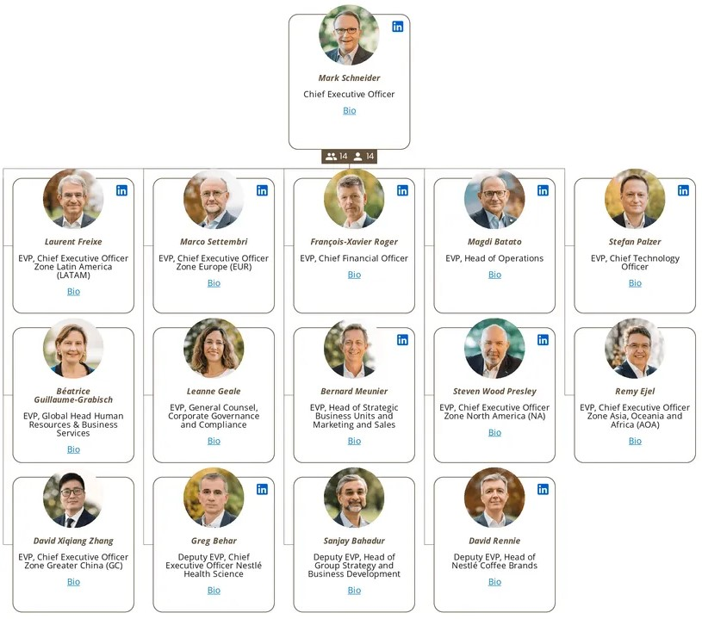Top of Form

**1.2 Environmental Analysis**

**1.2.1 Macro Analysis**

|  |  |  |
| --- | --- | --- |
| **Factors** | **Nigeria** | **Malaysia** |
| **Political Factors** | Government initiatives supporting local sourcing. | Positive government stance on foreign investment. |
|  | Policy changes and bureaucracy challenges. | Stable political environment. |
|  | Currency fluctuations affecting import costs. | Adherence to food and nutrition policies. |
|  | Market potential with a growing middle class. | Alignment with Vision 2030 for inclusive growth. |
|  | Operational challenges due to infrastructure weaknesses. | Potential collaboration on public health initiatives. |
| **Social Factors** | Emphasis on family and community in culture. | Cultural richness influencing culinary traditions. |
|  | Health awareness and eating habits evolving. | Strong emphasis on family and community. |
|  | Localization opportunities based on cultural diversity. | Growing environmental awareness and sustainability. |
|  | Consumer trends and preferences among the youthful population. | Religious sensitivities and halal certification. |
|  | Opportunities and threats related to environmental consciousness. | Health concerns influencing product portfolio. |
| **Technological Factors** | Integration of digital solutions for efficiency. | Leveraging technological richness and a skilled workforce. |
|  | Cybersecurity measures to safeguard data. | Digital initiatives for e-commerce and marketing. |
|  | Blockchain implementation for transparency. | Investment in research and development (R&D). |
|  | Utilizing nutritional information portals. | Smart farming technologies for agricultural efficiency. |
| **Environmental Factors** | Opportunities in government collaborations on nutrition and rural development. | Potential for sustainable practices and eco-friendly packaging. |
|  | Threats from regional instability and unpredictable policy changes. | Challenges in navigating complex regulations and potential social unrest. |
|  | Waste management concerns associated with plastic packaging. | Addressing the impact of technological advancements on environmental aspects. |
| **Legal Factors** | Challenges with import regulations and high import duties. | Opportunities in government incentives for food manufacturing and halal certification. |
|  | Complex land ownership laws and informal markets. | Compliance with new food safety and labelling regulations. |

**1.2.2 Micro Analysis**

**1.2.2.1 Consumer Analysis**

In Nigeria, consumer buying power can vary significantly among different income groups, influencing their purchasing habits. There is a strong emphasis on local and staple food products, and brand loyalty is often tied to indigenous brands. Cultural diversity plays a significant role in shaping consumer preferences. Economic fluctuations may impact spending patterns.

On the other hand, in Malaysia, consumer buying power is more evenly distributed across the population. Purchasing habits reflect diverse preferences influenced by a blend of various cultures. While there is loyalty to local brands, consumers also balance this with an affinity for international brands. Economic conditions in Malaysia are generally more stable, influencing consistent buying patterns among consumers.

**Top of Form**

**Similarities**

* **Product Portfolio:** Nestle offers a similar range of products in both Nigeria and Malaysia, including popular items like Maggi, Milo, Nescafé, and Nestlé Pure Life.
* **Local Adaptation:** In both countries, Nestle demonstrates a commitment to adapting its products to local market conditions, considering factors such as quality, size, and packaging.

**Differences**

|  |  |  |
| --- | --- | --- |
| **Aspect** | **Nigeria** | **Malaysia** |
| **Consumer Loyalty** | In Nigeria, the research focuses on the impact of advertising on consumer buying behavior, suggesting a reliance on continuous advertising to shape perceptions and drive purchases. | In Malaysia, Nestlé's success is linked to strong brand loyalty, particularly among the youth demographic, influenced by a reputation- and trust-driven culture. |
| **Market Dynamics** | Nigeria's consumer behavior analysis emphasizes Nestle's longstanding presence and commitment to improving the quality of life, aligning with the local market dynamics. | Malaysia's analysis highlights the influence of cultural factors, with a significant portion of the youth expressing loyalty to Nestlé's products, showcasing the impact of international trends. |

**1.2.2.2 Competitor Analysis**

**Nigeria Competitors**

**BUA Foods PLC**

* **Strengths*:*** BUA Foods exhibits impressive net sales revenue growth (80.95% in 2022Q3) and a positive operating profit margin (2.34% in 2022Q3). Their diversified portfolio, including sugar, flour, pasta, rice, and edible oils, strengthens their market presence.
* **Weaknesses*:*** The high debt-to-equity ratio (-19.92% in 2022Q3) could pose a vulnerability. Excessive debt may limit financial flexibility and hinder strategic investments, potentially impacting future competitiveness.

**Cadbury Nigeria PLC**

* **Strengths:** Cadbury Nigeria demonstrates robust net sales revenue growth (39.17% in 2022Q3) and a significant operating profit margin (8.52% in 2022Q3). Their diversified product range and a rising profile in the EMEA region contribute to their strength**.**
* **Weaknesses:** The exceptionally high debt-to-equity ratio (1623.45% in 2022Q3) could lead to financial strain. Managing such high debt levels may restrict future expansion and strategic initiatives.

**Fig 1.1**: Net Sales Revenue Growth Comparison of Nestle Nigeria Competitors

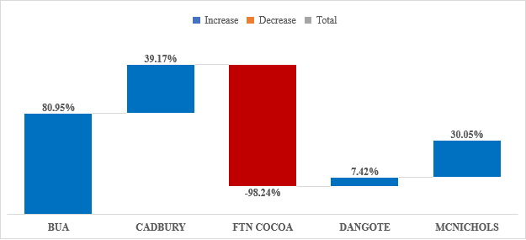

**Malaysia Competitors**

**Lindt & Sprungli**

* **Strengths*:*** Lindt & Sprungli boasts a strong net sales revenue growth (7.5%) and an impressive operating profit margin (18.5%). Their premium chocolate products and global presence position them as a formidable competitor.
* **Weaknesses:** Limited information on debt-to-equity ratio; however, the reliance on premium offerings may make them susceptible to shifts in consumer preferences.

**Mayora Indah Tbk**

* **Strengths*:*** Mayora Indah Tbk's strength lies in its diverse product range, contributing to net sales revenue growth (4.2%) and a solid operating profit margin (14.2%).
* **Weaknesses***:* Lack of available data on debt-to-equity ratio. Reliance on undisclosed revenue figures and workforce details might hinder a comprehensive analysis of their financial health.

**Future Threats for Nestle**:

The high debt levels of some competitors, such as Cadbury Nigeria and BUA Foods, could pose a future threat to Nestle. If economic conditions change or financial constraints limit their ability to invest in innovation or expansion, nestle may leverage this weakness to strengthen its market position. Additionally, the global trend toward healthier and sustainable products may impact competitors with less diversified portfolios, offering Nestle an opportunity to capitalize on changing consumer preferences